Senior Infant Booklist – Ms. S Rynhart
September 2021
Gorey Central School
Book Rental Fee: €25

ART/PHOTOCOPYING & 24hr pupil insurance: €45 (Please bring this money in a sealed, named envelope on the first day of term.)

Literacy: *Ready to Write B1- (An introduction to Cursive) Senior Infants (EDCO)*
*JollyPhonics Pupil Book 2 (Colour and PRINT version)
*Sounds make Words-Senior Infants - (FOLENS)*

Numeracy: * Planet Maths Senior Infants (FOLENS)
(also includes a free number workbook)*

Gaeilge: *Bua Na Cainte B (EDCO)*

NB Only books marked with an asterisk * will be purchased with the Book Rental Fee.
All other books or stationery below this line must be bought by parents / guardians

COPIES and FOLDERS: (Please refer to reference pictures on reverse)
- 2 x Project books (size 15A - 40 pages)
- 1 x Learn to Write JO9 15mm copy (40 pages)
- 1 x Learn to Write B2 copy (red and blue lines) (40 pages)
- 1 x 20mm square Maths copies (40 pages)
- 1 x A5 plastic folder (for reader)
- 1 x A4 plastic folder with zip (for homework)
- 2 x A4 flat plastic envelope folders (for worksheets)
- 1 x A3 plastic envelope folder (for worksheets and artwork)

EACH CHILD NEEDS:
4 x Faber Castell HB pencils (tripod grip are recommended)
1 x eraser
1 x ruler (15cm long)
1 x sharpener (with shavings catcher tub if possible!)
Colouring pencils (preferably colouring pencils rather than Twistables)
2 x large Pritt Sticks
Painting shirt / Old t-shirt

All books, copies and folders must be clearly named BEFORE the beginning of the new term.

Senior Infant
Copies and Folders reference pictures
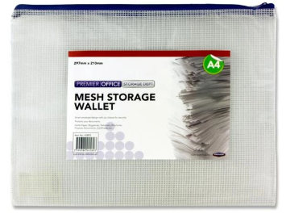  f | e  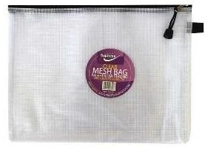
1 x A4 flat plastic folder | 1 x A5 flat plastic folder
g | 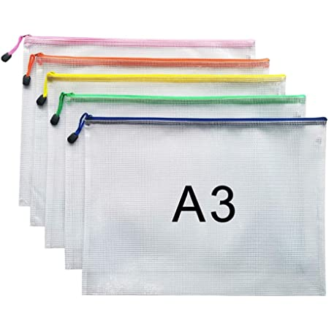  h
2 x A4 flat plastic envelope folders | 1 x A3 plastic envelope folder
d  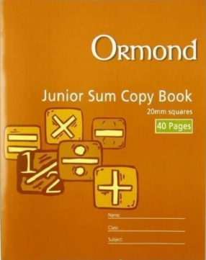 | a  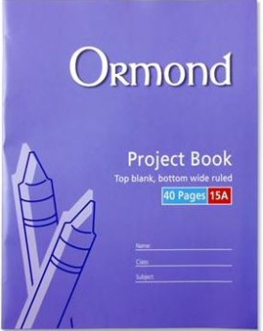
1 x Junior Sum Copy Book  (40 pages, 20mm squares) | 2 x Project Books  (40 pages, No. 15A)
b  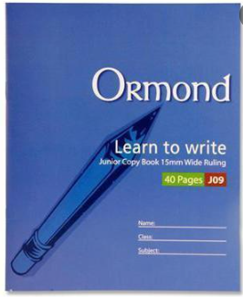 | c  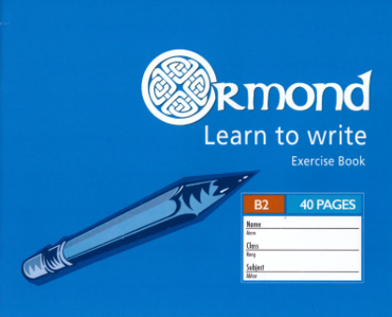
Learn to Write JO9 15mm copies | 1 x Learn to Write B2 copy (red and blue lines) (40 pages)

