Junior Infant Booklist – Mrs E Leech:
September 2021
Gorey Central School
Book Rental Fee: €25

ART/PHOTOCOPYING & 24hr pupil insurance: €45 (Please bring this money in a sealed, named envelope on the first day of term.)

Literacy: *Ready to Write A1-Junior Infants (EDCO)*

*Sounds make Words-Junior Infants - 42 Sounds (Folens)*

Numeracy: * Sum Detective (Folens)*

Gaeilge: *Bua Na Cainte A (EDCO)* Edco

NB Only books marked with an asterisk * will be purchased with the Book Rental Fee.
All other books or stationery below this line must be bought by parents / guardians

COPIES and FOLDERS: (Please refer to reference pictures on reverse)
1 x A4 flat clear plastic folder
1 x A5 flat plastic folder
2 x A4 flat cardboard envelope folders
1 Sum Copy Book (40 pages, 20mm squares)
1 Project Book (40 pages No.15A)

EACH CHILD NEEDS: 3 HB Writing pencils
1 Rubber
1 packet 12 Crayola Twistable Crayons (NB no markers)
2 Large Pritt Stick
1 Sharpener

All books, copies and folders must be clearly named BEFORE the beginning of the new term.

Junior Infant
Copies and Folders reference pictures
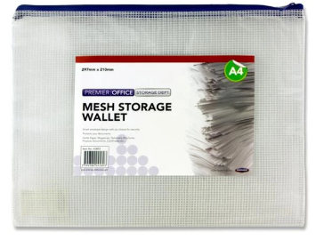 | 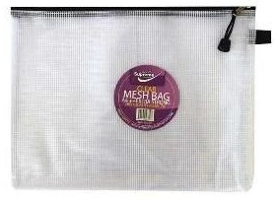
1 x A4 flat plastic folder | 1 x A5 flat plastic folder
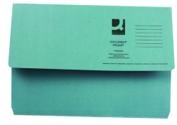 | 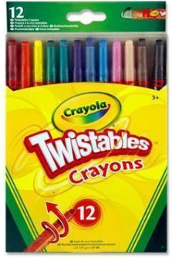
2 x A4 flat cardboard size folders | 12 Crayola Twistable Crayons
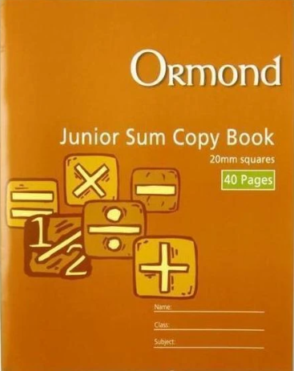 | 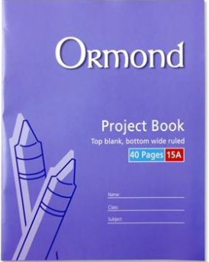
1 x Sum Copy Book  (40 pages, 20mm squares) | 1 x Project Book  (40 pages, No. 15A)

