Senior Infants
Booklist 2020 / 2021
Gorey Central School
Art and Photocopying + 24 hour Pupil Insurance = E45
- Please bring this to school in a sealed, clearly named envelope on the first day of term

Literacy: Ready to Write B1 (Intro. To Cursive) EDCO
Sounds in Action Senior Infants Folens
Jolly Phonics Pupil Book 2 (Colour and Print version)

Numeracy: Planet Maths B Senior Infants Folens (includes free number workbook)

Gaeilge: Bua na Cainte B EDCO
Only books marked with * asterix will be purchased with Book Rental Fee. All other books and stationery must be bought by parents/guardians
Copies and Folders: Homework Diary – FOLENS
2 x A5 flat plastic folders
1 x A4 flat plastic folder
1 x sum copy (22cm sq)
2 x Project books (no. 15)
1 x Headline/Handwriting copy (B2)
2 x Blank copy
Stationery: 4 x HB writing pencil
1 x eraser
1 x set of colouring pencils (not markers)
2 x LARGE Pritt Stick
1 x sharpener
1 x pencil case
*Please carefully and clearly name all books, copies, folders and stationery BEFORE the beginning of term

Please use the following to assist in the purchase of copy books and folders:

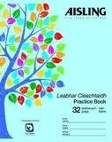Blank copy 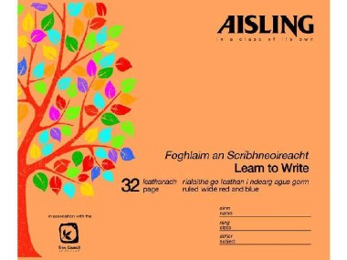Headline/Headline copy

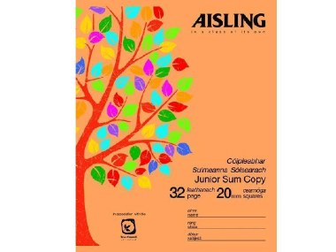Maths copy 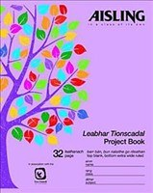 Project book (15)
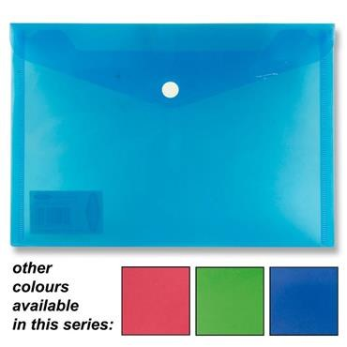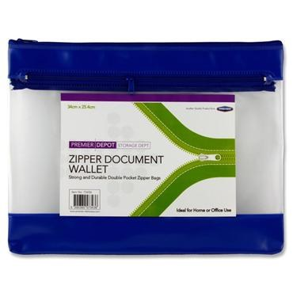
A5 flat plastic folder (for reader) A4 Plastic folder (for homework)
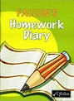Fallon’s Homework Diary

