2nd Class Booklist- Teacher–
September 2020 - Gorey Central School

- ART/PHOTOCOPYING & 24hr pupil insurance: €45.
(Please bring this amount in a sealed, named envelope on the first day of term)

- Class Sets and Individual Workbooks will be purchased with the Book Rental Fee.

- Stationery and Copies/Folders must be bought by parents/guardian.

- All workbooks, copies and stationery should be covered and named prior to your children returning to school in September.

- All workbooks are used as a teacher tool to deliver the appropriate curriculum content. Teachers will use their training to deliver the required curriculum content using many forms of pupil work. A teacher has full discretion to create their own worksheet or explore other textbook options if they feel it better suits the children and their style of teaching. It is for this reason that not every work book will be fully completed by the end of the academic year. Please be reassured that this does not mean that children have missed topics it just highlights the efforts class teachers have made to provide your children with the best access to the curriculum they can.
Class Sets | Individual Workbooks
MATHS  - Planet Maths 2 Folens  - Time for tables EDCO  MUSIC  - The Right Note 1st and 2nd Class Folens  SESE  - Window on the World 2 for 2nd class EDCO | MATHS  - Tables Champion: Tables for 2nd Class Educate.ie  - New Wave Mental Maths for 2nd class Prim-Ed  ENGLISH  - Ready to Write D1 – Cursive EDCO  - Jolly Grammar 2 Pupil Book Jolly Learning limited  - Chambers New School Dictionary CJ Fallon (see image below)  GAEILGE  - Bua na Cainte 2 EDCO
Stationary | Copies/Folders  (see overleaf for samples but please do remember that copy colour and the number of pages will vary depending on the brand)
4 x Faber Castell HB pencils  1 x eraser  1 x ruler (30 cm long)  1 x ruler (15cm long)  1 x sharpener (with shavings catcher tub if possible!)  Colouring pencils (preferably colouring pencils rather than Twistables)  2 x large Pritt Sticks  Painting shirt / t-shirt | a)4 x Project books (size 15A - 40 pages)  b)6x A12 copies (40 pages)  c)1 x A4 Display Book (at least 40 pockets)  d)4 x 10mm square Maths copies (40 pages)  e)2 x Spelling Notebook (Premier Note Book 100 pages)  f)1 x A5 plastic folder (for reader)  g)1 x A4 plastic folder with zip (for homework)  h)1 x A4 paper folders (for worksheets)  i)1 x A3 plastic envelope folder (for worksheets and artwork)  j) Fallons Homework Diary
**Copies/folders and stationery should all be named
prior to your children returning to school in September*
f
j
a
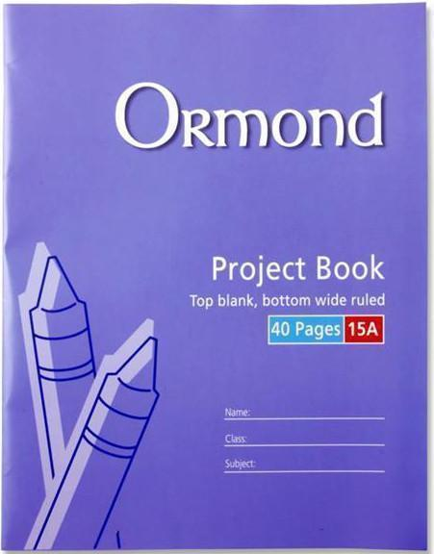
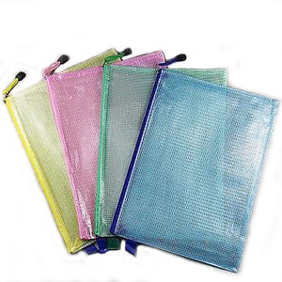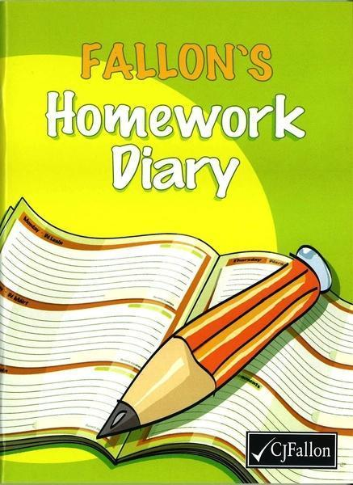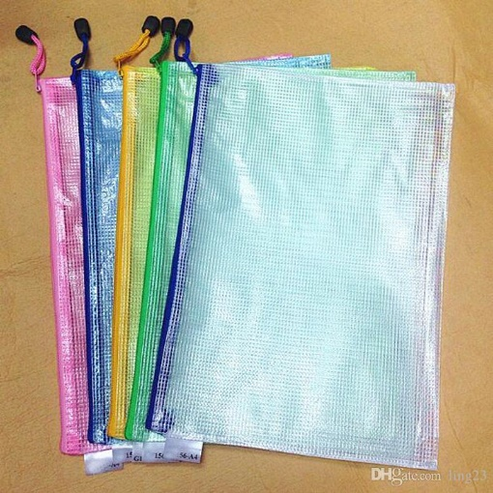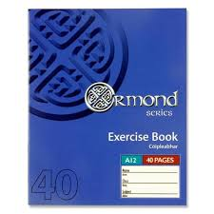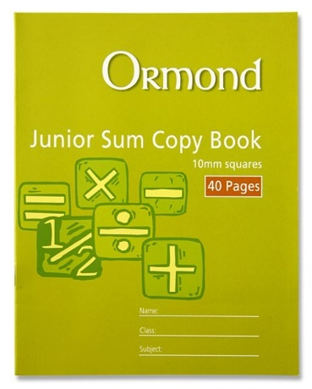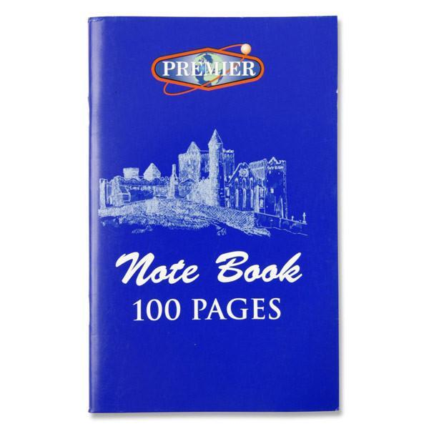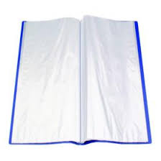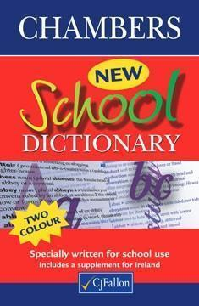
e
*Colours may vary depending on brand etc.
g
b
d
c

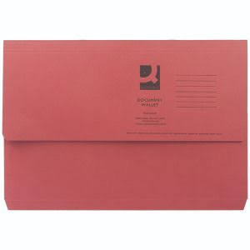
i
The same style as ‘h’ or ‘g’, but A3 in size.
h

