Newsletter No. 4

February 2020

Dear Parents/Guardians,
It is hard to believe how quickly the time has gone since Christmas and now St. Patrick’s Day is upon us!

- Dates for your Diary:
- St. Patrick’s Day: School closed on Tuesday 18th March.
- Easter Holidays: School closes Friday 3rd April at 12.30pm & re-opens Monday 20th April at 8.40 a.m.

- Junior Entrepreneur Programme:
Junior Entrepreneur Programme (JEP): The pupils from 5th and 6th class 'Met the Dragons' on Friday, 7th February and pitched their ideas to them. One idea was chosen from Ms. Furney's room and one was chosen from Ms. McDermott's room. Both classes are working really hard on their winning ideas. We are delighted to invite you all to the Junior Entrepreneur Showcase Day here in Gorey Central School on Wednesday, 1st April at 11am. We are all very excited! Watch this space! Ms. Furney and Ms. McDermott

*** Our Showcase Day will take place in the school hall on
Wednesday, 1st April at 11.00am***

- Gorey Altura Credit Union Quiz:
Two teams were entered into the Altura Credit Union quiz in February. Following on from in-school heats in 4th, 5th and 6th classes, eight students went forward to the quiz, which included schools from all over County Wexford. There were some very tricky questions on the night, but the children did very well and enjoyed the experience. Well done to Dylan Cooper, Rosie Rothwell, Zach White and Robin Sunderland on the Senior Team and to Shauna Owens, Izzy Hughes, Kayla Page and Laura Halnon on the Junior Team!

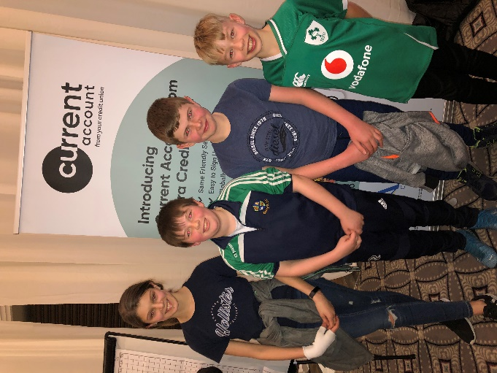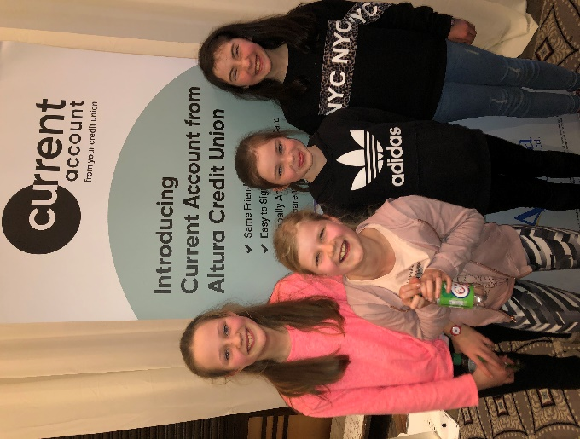

- Aldi Poster Competition:
Well done to the children and parents for filling our Aldi Rugby poster with player stickers. So far we have filled two posters and are working on filling up a third. Please keep the stickers coming if you have any. Thank you!

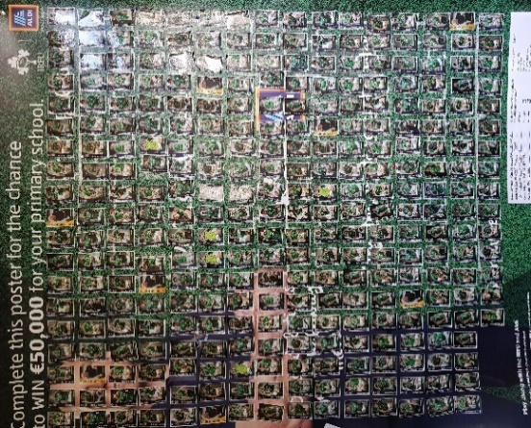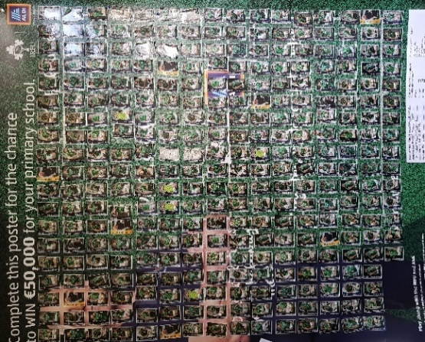

- ESB Science Blast:
3rd class did extremely well at the recent ESB Science Blast in the RDS on Tuesday 3rd March. There was great excitement spotting the ‘worm bus’ (our question on the Dublin buses) on the way to the RDS!! The children had a fantastic day showing off their project: ‘How do worms move?’ They also interacted with lots of the onsite exhibitions and shows. The children were very confident during their interactions with the judges and children from other schools. They used all the correct terminology and explanations. We were very proud of them. The judges were very impressed with the children’s hard work and understanding that they awarded the children a trophy and a prize of a free school tour!! We look forward to our next day out.
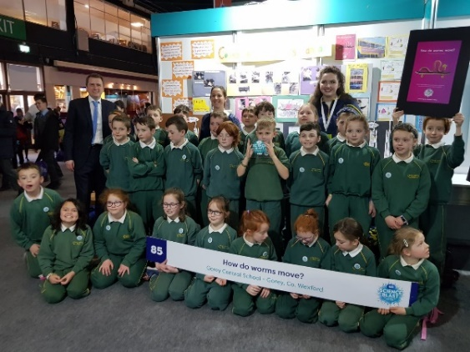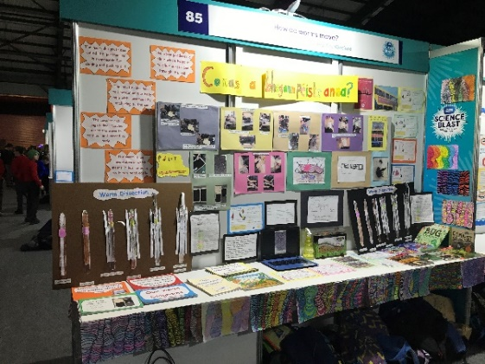

- YEA – 5th Class: The Cool Climate Clan
5TH Class qualified for the Semi Finals of the YEA Award and are looking forward to their presentation on Thursday 19th March in UCD where 6 members of the Cool Climate Clan will stand before a panel of judges to present their findings.
Part of the project is to promote awareness in the school and community. 5TH class have been busy presenting their findings to the school children in an assembly and in individual classes through the use of child friendly resources, books and much more.
You recently received an email with our lovely class brochure which entailed ‘10 tips and tricks for a greener world’ simple ways to reduce the use of single use plastic. We all hope you have had a chance to read it and decide on one thing you can try to change.
In this newsletter we would like to take the time to present another one of our little projects: A Bin sticker! Did you know:
- That soft plastics cannot yet be recycled in Ireland?
- If you can scrunch it…..it’s not recyclable!!!
- Only some hard plastics are recyclable!

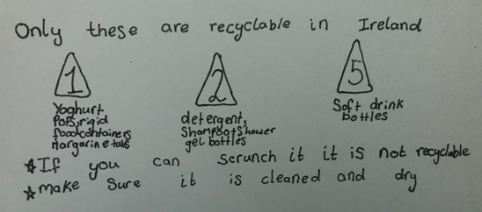

- Green Schools - Students Go Green As They Hit The Streets:
As part of the Green-Schools Programme, Gorey Central School began working on earning their fourth Green School Flag which comes under the theme of ‘Travel’ this school year. The travel theme focuses on changing our relationship with the way in which we travel to school, so that more environmentally friendly methods of travel are used more frequently. The theme aims to normalise walking, cycling and scooting so that we can get to a level of active travel that our grandparents would recognise. The Travel committee have worked hard gathering data on how all pupils travel to and from school. This data will be used to encourage more sustainable options of travel such as carpooling, Park ‘n’ Stride and bus.
Sixth class pupils took part in a 6 week programme run by Southeast Cycling Safety which aims to encourage road awareness and road safety. The children spent 4 weeks using bicycles around the school premises, when they were taught the skills required to assess situations which may occur on the road and how to react to them. In the last two weeks, sixth class have taken to the open road and demonstrated to all who have witnessed them how beneficial this programme can be. This has been a fantastic experience for the children and we hope that they are able to take the lessons they have learned and utilise them. This will ensure that they are safe while cycling and also saving the environment in the process.
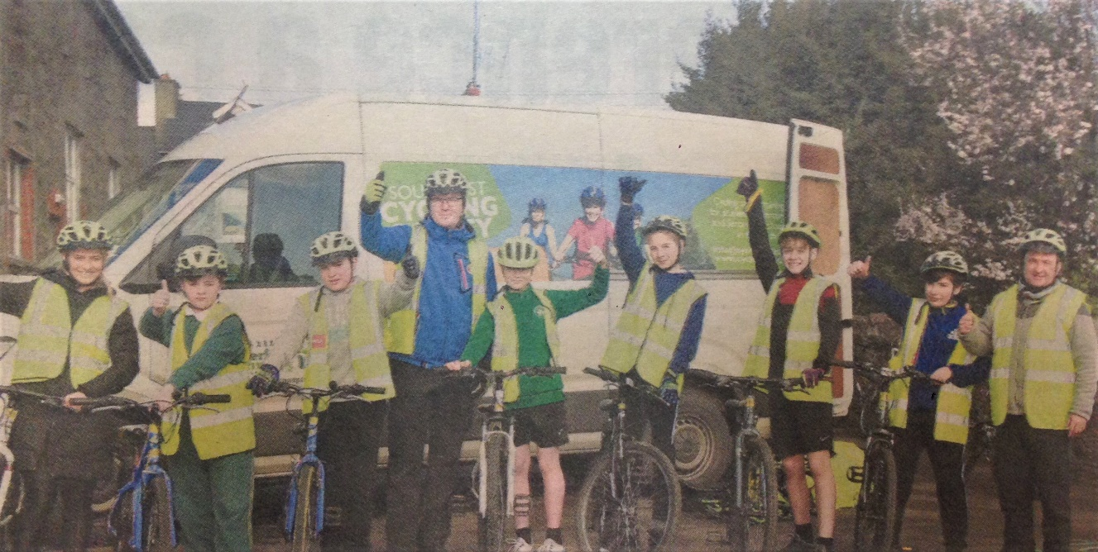

- GAA Blitz:
Huge congratulations to all the boys and girls who took part in the local GAA Blitz in Kilanerin recently. All children had an amazing day and represented the school with pride. A big well done to the boys’ team who beat off stiff competitors and won the competition in true GAA style by the narrowest of margins in the final. It has been amazing to see the dedication and effort that all children have put into the GAA over the past few months and their hard work really paid off on the day! The improvements that have been made by all the children has been immense and the continued take-up of GAA is great to see. Well done G.C.S. GAA teams! Ms. Jordan. Ms. Cousins, Ms. McDermott
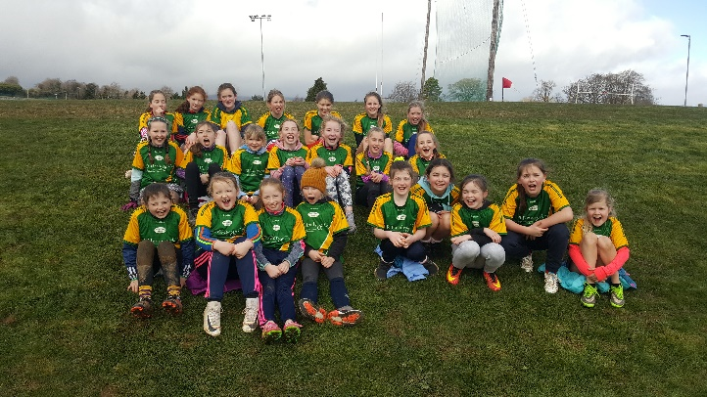
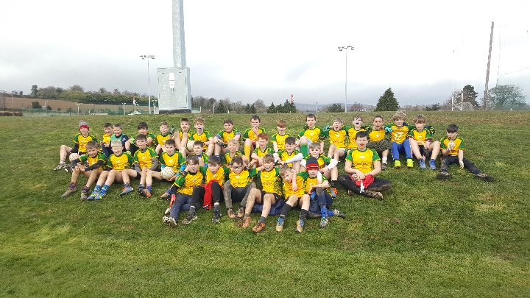

- Interschool’s Equestrian Success:
Congratulations to Lauren Adams, Emma Poole, Zoe Poole and Holly Spencer. The girls recently placed 1st in the recent Interschools Ireland competition in Barnadown. Well done girls! Congratulations also to Emma who came third in the Individual Competition.

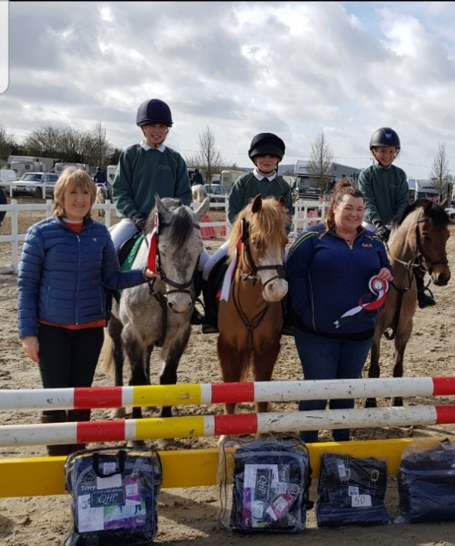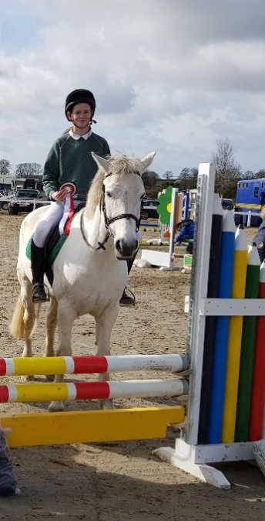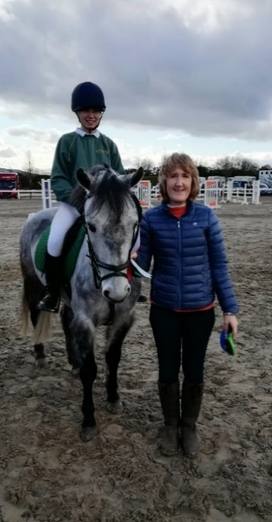

- Garda Vetting:
Thank you to those who have recently filled out a Garda Vetting form. Your help is very much appreciated. For those of you who would like to apply for Garda Vetting forms are available from Charlette in the office.

- Seasonal Illnesses and COVID - 19
In an effort to prevent the spread of infection we ask that you do not send your child in to school if they are unwell (e.g. coughs, colds, etc.). If your child has symptoms such as vomiting or diarrhoea, Department of Education rules require that pupils should not return to school until 48 hours have passed since their last episode of either vomiting or diarrhoea.
Regarding Covid-19, please familiarise yourselves with guidelines from the Department of Health, its symptoms and the steps everyone can take to protect themselves. These can be seen on HSE.ie and Gov.ie/health.
A big thank you to Ms. Catriona Roche who kindly came in to demonstrate and run through recommended practices for hand hygiene.

- Food Allergies/Treats:
Please be reminded that we have a number of children with life threatening allergies to nuts. Our entire school is a nut free zone. Please check the ingredients in lunches coming into school as there may be traces of nuts in them, and practise good hand hygiene before your children come to school each day as they may have encountered traces of nuts away from school.
Only one small treat is permitted on Fridays. Some children are bringing in large share bags of treats which is not allowed.

- School Uniforms:
Could we please ask parents to make sure that all uniforms and coats are clearly named. It can be very stressful for everybody/children (and parents!) if they get mixed up or mislaid.

- 6th Class Fundraiser:
6th class pupils will be hosting a Fundraiser in aid of our school, as well as Pieta House and Rainbows. This event will be done in conjunction with our school's Amber Flag. We will be hosting a TABLE QUIZ on 2ND APRIL in AMBER SPRINGS hotel. Please see email with poster attached for additional information.

Kind regards,

Mr. Bater

