Newsletter April/May 2019

Dear Parents/Guardians, the following points are for your attention:

School Emails and Texts:
Emails received from office@goreycentral.com cannot be replied to. This is the email system within Aladdin, our office admin package, and is a 'no-reply' email.
The school email goreycentralschool@gmail.com should be used.
Texts received from school cannot be replied to either as they are also sent from Aladdin.

- Family Contributions:
Thank you to all families who have paid their family contributions for this school year. We would be grateful if any outstanding payments could be made as soon as possible. The amounts are as follows – and again, thank you to those who have already paid:
- 1 Child: €100.
- 2 Children: €125.
- 3 or more Children - €150.

Book Rental:
We will be running our Book Rental Scheme again this year. A letter will issue to all parents shortly inviting you to participate. Please note that any families currently availing of this year’s scheme will be asked to return the books to the school in good condition later in the term. However, please note that any books lost or damaged must be paid for in full less the rental charge by June 27th 2019.

Bunny Hop:
Junior and Senior Infants enjoyed a “Bunny Hop” to Gorey Town Park on Tuesday 9th April for Down Syndrome Ireland. Thank you to all the parent helpers who came. We raised a wonderful €155 for the Down Syndrome Centre. Well done to all!

STEM (Science, Technology, Engineering and Maths):
Gorey Central School have submitted an application for the STEM Plaque of Excellence this year along with a Pilot schemed Badge of Excellence. Many thanks to Lisa O’Donnell, Cheryl Poole and Lorna Stephens along with teachers Mrs Emma Leech and Ms Emma Furney for their assistance with the Badge application. We are waiting to hear how we got on-fingers crossed!
What does this initiative involve???....LOTS!
Work in the area of Science this year included exciting classroom experiments to cover all aspects of the Science Curriculum:
- Children in 3rd class took part in the “ESB Science Blast” which saw them discover and learn all about magnetism. They then brought their project up for display in the RDS in March where they were questioned and judged on their project. They got to enjoy wonderful activities and shows while they were there and they came home with a fantastic award for the efforts.
- There were school visits to Gorey Library as part of Science week so that the children could attend a workshop on Electricity.
- 3rd class created a new school garden at the side of the entrance to the school and are growing fruit and vegetables as part of the Incredible Edibles Programme.
- There have been bug hunts and insect and bee hotels made.
- A magician come to the school to promote caring and sharing for our environment and those we share it with.
- Lorraine Doyle, a Heritage Specialist from Heritage Ireland, came to the school to teach workshops about pond and river life. The Senior Classes thoroughly enjoyed their Heritage Field study to Altamont Gardens and put what we learned into practice. The Junior Classes will go on June 12th.
Work in the areas of Technology this year included:
- The children have been busy using the school iPads to access educational games in the areas of Maths and for learning in projects and research.
- 6th class had a visit to Waterford Institute of Technology where they created robots and viewed a Supercomputer.
- Workshops were arranged for the junior end of the school in May during Tech Week to allow the younger children opportunities to Pixilate in Junior and Senior Infants and Code Cracking for 1st and 2nd Class. This was enjoyed by all.
Work in the areas of Engineering this year included:
- All children took part in Lego workshops during Engineering Week where they worked together to design and build cities and harbours with Lego.
- 3rd and 4th Class took part in the STEPS Engineering Programme this year where they created prototypes for their ideas and presented them to the other classes and a visiting Engineer. We had one finalist project within this programme.
- 5th and 6th class took part in JEP again this year which included team building work and their showcase day which was put on for the whole school community.
Work in the areas of Maths this year included:
- During Maths week, the Senior Classes had access to IZAK 9 which is a large Maths resource which allows for group work in Problem Solving and working together which the children love.
- Other classes did exciting activities for Maths weeks including Maths trails around the school grounds with their classroom buddies.
- 3rd and 4th Class did baking as part of maths. This included a new Cooking Programme called “Cooking All Stars” which teaches lots of aspects of food and allows the children opportunities to cook while learning basic cooking techniques for life.
Work in the areas of Show and Tell this year included:
- Probably the biggest thing that we worked on within STEM this year was giving the children opportunities to present their work to their peers, other classes, parents and the wider community. This was done through the following:
- STEPS Presentation Day for their peers and visiting Engineer and another day for the whole school in the school hall.
- The ESB Science Blast which took place in the RDS in Dublin.
- JEP Showcase Day for children, parent and teachers

Altamont Gardens:
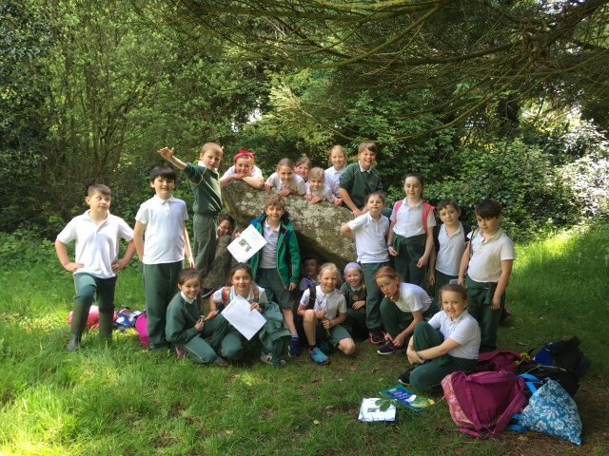
3rd, 4th, 5th and 6th Class had a fantastic and very educational trip to Altamont gardens. We did a bug hunt, a scavenger hunt, identified leaves on all the different types of trees. We did a habitat drawing by the river, had a fantastic bird and flower talk by local groundskeeper Paul and of course the Heritage Specialist Lorraine Doyle gave a fantastic talk and hands on workshop of pond and river life where the children identified the different creatures living in the pond and river. Junior Infants, Senior Infants, 1st Class and 2nd Class will also be attending Altamont Gardens in the coming weeks. All the children in Gorey central School would like to thank the PTA for sponsoring this fantastic trip that will be one the children will never forget.

Incredible Edibles:
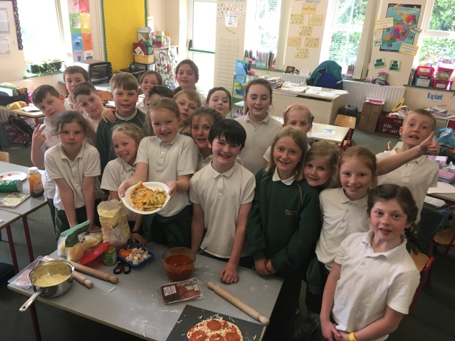
The children in third class have been very busy working on their Incredible Edibles Project which is due next month. We have helped to create and maintain the new school garden! You can now visit our compost area, bee hotels, positivity rocks, sunflowers, herbs, fruit and vegetables, bird feeder, rainwater harvester and insect hotel to name just a few! We are busy completing our log book for the project and one of the criteria was to cook a meal using potatoes, vegetables and herbs. The children peeled potatoes for chips, made homemade hidden vegetable pizza sauce, pizza bases and toppings to create a fab meal. Well done third class! Let the fun continue with our upcoming Drama show for the whole school and parents: ‘There’s a Sunflower in my Supper!’.

Green Schools:
Before the Easter Break we received the exciting news that we have been granted our third Green school flag for Water. This was announced in assembly recently. Lilli Cooper and Isaac Hughes, from the Green Schools Committee, have been selected to attend an award ceremony in Kilkenny, where they will be presented with our new flag. We are looking forward to seeing it fly alongside our other flags very soon.
Mrs. Poole and Mrs. Cousins.

Seal Rescue Ireland Workshop and Adoption:
Ms McDermott’s students visited the library for a workshop from Seal Rescue Ireland. This consisted of their interactive Marine Conservation Discovery Tour exploring seal ecology, threats to both seals and the oceans, as well as what everyone can do to help reduce their human impact. A follow-up eco brick workshop allowed a chance for the children to have a go at eco bricking, learning the importance of correctly disposing of soft plastics and inspiring them to start eco bricking at home and school. We were also able to sponsor and adopt one of the seal pups in the rescue centre, where the class followed the rehabilitation progress of Pistachio the pup. We have received updates over the last few weeks and some of the students attended her return to the sea on Courtown’s North Beach last week.

Junior Entrepreneur Programme:
5th and 6th class recently hosted our Junior Entrepreneur Programme Showcase Day! The students created decorated pencil-holder jars, decorated pencils and some tasty treats. We also held a raffle and a 'guess how many eggs in the jar' competition. We were delighted to see so many family, friends and members of our school community coming to visit and support us on the day. It was a great success and we practically sold out so thank you to everyone who attended. The students in 5th and 6th class also made the decision to donate a large portion of the profits to the Hope Cancer Support Centre in Enniscorthy and they should be highly commended for this very generous contribution to a very worthy charity.
We have now completed our Junior Entrepreneur Programme folder and sent it away to illustrate all of the hard work that we have put into our project this year. We also attended the National Junior Entrepreneur Showcase in the RDS on Monday 20th May which was a fabulous experience for all.

Aldi’s Play Rugby Festival:
6th class travelled to Ashbourne RFC to take part in the Aldi Play Rugby Festival. They had the opportunity to play against many different teams from all over Leinster. Fortunately the weather was great and we all had a fabulous day. We attended the National Festival in the Aviva Stadium on 22nd May. 6th class were delighted when they got the news and had an amazing day out. What an experience!

Pangea Mathematics Competition:
All of the students in 5th and 6th class took part in the Pangea Maths Olympics competition. The Maths Olympics is a fun and challenging competition for the primary and secondary students. A huge congratulations to Eli Page, who was selected in the 5th class category as a results of the amazing scores. He was invited to attend the national final in Trinity College Dublin and he did very well on the day. Well done Eli!

Heritage Ireland 2030:
Heritage Ireland ran a competition aimed at in 5th and 6th class to design and emoji that reflects the pupil’s ideas in relation to heritage, history and tradition in Ireland. Well done to all pupils who entered their creations to the county stages and a special congratulations to Rosie Rothwell (5th class) who placed first in her year group and to Sína White (6th class) who placed third in her year group. Their designs will now be entered into the competition at a regional final. Good luck girls!

Family Fun Day:
I would like to extend a huge thank you for the amazing support that our school received at our recent fundraiser, all involved had a wonderful day! A special thanks must go to our PTA and parent volunteers who helped in the preparation of this event and on the day. The BBQ kept them very busy. Although we have not calculated a final figure raised as of yet, it is fair to say that our children’s fundraising efforts were nothing short of amazing. Most of all, the day provided us with an opportunity to sit back and admire the strength of our school community. Staff, parents, children, grandparents, aunties, uncles, friends and many more supported the event in one way or another. Once again proving that Gorey Central is more than just a school. We are also very grateful to the generous sponsors of our raffles prizes.

Raffle winners were as follows:
Gordon Bailey, Jack Kenny, Harry and Jamie Sykes, Paul Maguire, Kate McDermott, Laura Halnon, E. Allen, Gary Adams, Hazel Tomkins, Darren Langrell, Simon Nelson, Beverley Jones.

Music Concert:
Over the course of the year, children in the school have experienced a wide range of music tuition. To demonstrate the musical talent we have on show here in Gorey Central School, I would like to invite parents to our second musical concert on Thursday 13th June. The concert will start at 1:20pm sharp and will include tin whistle performances from 3rd-6th class accompanied by Ukulele and Guitar performances. I would like to thank Jacqueline Symes for her wonderful support in developing music within the school.

Interschool’s Soccer Blitz:
Just a reminder that the annual Soccer Blitz will then take place in Naomh Eanna on Friday 7th June from 9.30am. Children from 1st Class upwards are to wear shin pads while soccer boots are recommended.

17. School Uniform:
Please ensure that uniforms are clearly named. This ensures that children can easily identify their own uniforms. School shorts are available to buy in the office at a cost of €15. If you are interested in purchasing school shorts to accompany your child’s uniform please contact Charlette in the office.

18. Annual Diocesan Choral Festival:
This year’s Choral Festival will take place in St Aidan’s Cathedral, Ferns, on Friday 14th June at 11am. Students will come to school as normal and will travel to and from Ferns on buses to attend the service. Parents, guardians and family members are more than welcome.

Please note the following:
- A small collection will be collected from children and adults during the service.
- Full clean uniform is to be worn.
- There will be no refreshments afterwards and the children will return to school on buses. School will finish at 2.30 pm as usual.
- Any children not attending the Choral Festival will be marked absent on the School Attendance Roll for that day.

Website:
Don’t forget to keep an eye on our website for updates on everything we do in Gorey Central School. http://www.goreycentral.com/

20. Dates for your Diary:
- Bank Holiday Closure: Monday 3rd June and Tuesday 4th June
- Soccer Blitz Friday 7th June
- Choral Festival: Friday 14th June
- Annual Sports Day: Wednesday 19th June
- Summer Holidays: Friday 28th June @ 12 midday.

